**Module-6**

**MCQ Questions**

*16. In your program you want to use the JDBC-ODBC Bridge driver. What code do you use?*

*1.* ***Class.forName("sun.jdbc.odbc.JdbcOdbcDriver");***

# 2. Class.callName("sun.jdbc.odbc.JdbcOdbcDriver"); 3. Class.Name.init("sun.jdbc.odbc.JdbcOdbcDriver"); 4. Class.callfunc("JdbcOdbcDriver");

|  |
| --- |
| *17. Suppose a callable statement is created as follows:*    *CallableStatement callableStatement = connection.prepareCall( "{call sampleProcedure(?, ?, ?)}");*    *Assume that the first parameter is an IN parameter with value John. To set this parameter value, use* |

*1.* ***callableStatement.setString(1, "John");***

# 2. callableStatement.setString(0, "John"); 3. callableStatement.setString(1, 'John'); 4. callableStatement.setString(0, 'John');

|  |
| --- |
| *21. Suppose a prepared statement is created as follows:*    *Statement preparedStatement = connection.prepareStatement*  *("insert into Student (firstName, mi, lastName) " + "values (?, ?, ?)");*    *To set a value John to the first parameter, use* |

# 1. preparedStatement.setString(0, 'John'); 2. preparedStatement.setString(0, "John"); 3. preparedStatement.setString(1, 'John'); 4. **preparedStatement.setString(1, "John**");

*44. Which of the following statements are true?*

1. ***You may create multiple connections to a database.***
2. ***You many create single connections to a database.***
3. ***None.***

43. [CHAPTER-3-1] Some of the tasks in the general problem-solving model are listed below. Which of the following list these tasks in the correct sequence?

1. Problem definition, Finding solutions, Problem redefinition.
2. Data gathering, Finding solutions, Finding ideas.
3. Problem definition, Data gathering, Problem redefinition.

Answer: C

60. [CHAPTER-3-18] Consider the following statements about CASE tools.

Current CASE tools can perform semantic checks on a set of diagrams modelling an information system.

Current CASE tools can perform syntactic and consistency checks on a set of diagrams modelling information system. Current CASE tools can perform syntactic checks on a set of diagrams modelling information system.

Which of the following is true?

1. Statements A, Band C are true.
2. Statements A and C are true.
3. Statements B and C are true.

Answer: C

65. [CHAPTER-4-4] What do all objects have? A) State, behaviour and identity.

1. Behaviour, data and identity.
2. Instances, structure and similarity.

Answer: A

71. [CHAPTER-4-10] What is generalization?

1. A process of broadening the scope of an object, such that it becomes more gen12ally useful.
2. A kind of relationship between a more general element and a more specific element.
3. A process of collecting together objects into their respective classes.

Answer: B

80. [CHAPTER-4-19] Which of the following best describes encapsulation?

1. The implementation of an object can only be changed by its original programmer.
2. Data within an object can only be accessed by passing a valid message to one of its own operations.
3. Data within an object can only be accessed by passing a valid message to its class. Answer: B

Which of the following does the Figure below show?

**Image**

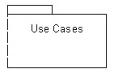



 **A)** A model.



 **B)** A sub-system



 **C)** A package





Which of these figures is a collaboration diagram?



**A)**



**B)**



**C)**

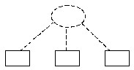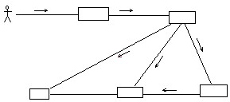

One of these is **not** a permitted symbol for an entity class. Which one?

**A)**





## 13

**B)**

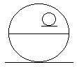

**CORRECT**





**C)**



 1. What is the disadvantage of Traditional life cycle?

The process is difficult to manage

The risks may not be completely determined even at the final stage of the project

 2. What is the best advantage of abstraction?

Abstraction is selecting data from a larger pool to show only the relevant details to the **object**. It helps to reduce programming complexity and effort. In Java, abstraction is accomplished using Abstract **classes** and interfaces. It is one of the most important concepts of OOPs

 3. What is called data about data?

A data date, also known by the two letter abbreviation DD, refers specifically to the date in the life of an ongoing project upon and through which the previously defined system of reporting for that given project is to provide the actual status of that project and the accomplishments attained in regards to that.

 4. What is called the ability of different methods to implement same operation in different way?

**5)  Which method is used to move cursor next line?**

rs.next();

**6)Which extensible language add new element?**

XML

**7)Which symbol is used to add one or more value/data?**

<!ELEMENT **cc\***(#PCDATA)>

**9)<!Element Email (To+, From, cc*, subject, body)?**

<!ELEMENT to(#PCDATA)>

<!ELEMENT **From**(#PCDATA)>

<!ELEMENT **cc\***(#PCDATA)>

<!ELEMENT **subject** (#PCDATA)>

<!ELEMENT **body**(#PCDATA)>

**10)Which features for UML?**

Objects are the real-world entities that exist around us and the basic concepts such as abstraction, encapsulation, inheritance, and polymorphism all can be represented using UML. UML is powerful enough to represent all the concepts that exist in object-oriented analysis and design

 11.

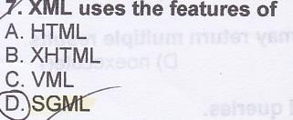



 12.



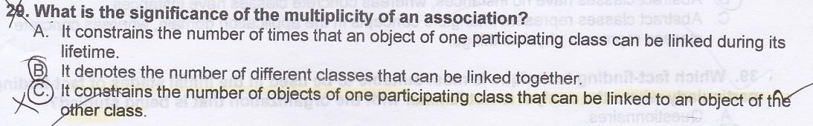

1. 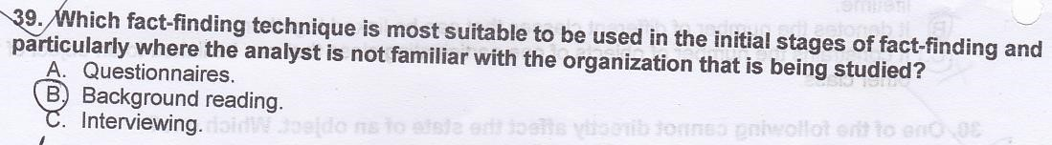
2. 

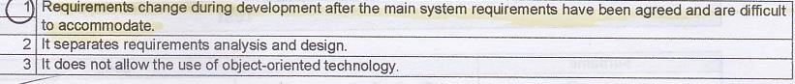

1. 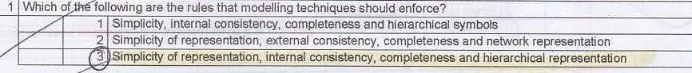

1. 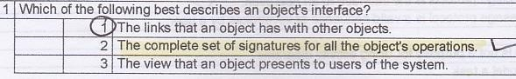
2. 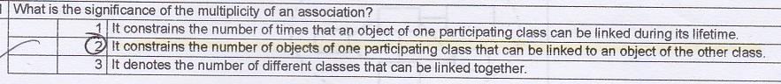

1. 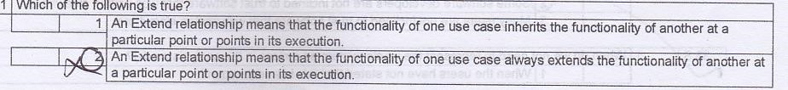



Final Descriptive module - 6

1. **Draw phases of water fall life cycle.**

The steps are:

* 1. System Engineering
  2. Requirement analysis
  3. Design
  4. Construction
  5. Testing
  6. Installation
  7. Maintenance

1. **What is the function of boundary class?**

*Boundary class:* This is the first type of an analysis class. In a system consisting of a boundary class, the users interact with the system through the boundary classes.

1. **What is the advantages of XML?**

(i). XML is platform independent and programming language independent.

(ii). XML supports Unicode.

(iii).XML is not limited to the fixed set of tags.

(iv). XML is extendable.

1. **What is XML namespace and why do we use it?**

XML namespace is a method or system by which we can divide two parts which are element and attribute.

**XML namespaces** are used for providing uniquely named [elements](https://en.wikipedia.org/wiki/Data_element) and attributes in an [XML](https://en.wikipedia.org/wiki/XML) document. They are defined in a [W3C](https://en.wikipedia.org/wiki/W3C) [recommendation.](https://en.wikipedia.org/wiki/W3C_recommendation)

1. **What is the advantages of DTD?** Advantages of using DTD
   * **Documentation** − You can define your own format for the XML files. Looking at this document a user/developer can understand the structure of the data.
   * **Validation** − It gives a way to check the validity of XML files by checking whether the elements appear in the right order, mandatory elements and attributes are in place, the elements and attributes have not been inserted in an incorrect way, and so on.

**6: What is a JDBC DriverManager?**

A: JDBC DriverManager is a class that manages a list of database drivers. It matches connection requests from the java application with the proper database driver using communication subprotocol.

**7.What is the purposes of JDBC?**

(i)Connect to a data source, like a database.

(ii)Send queries and update statements to the database

(iii)Retrieve and process the results received from the database in answer to your query.

**8: What are the basic steps to create a JDBC application?**

1. Create an instance of a JDBC driver or load JDBC drivers through jdbc.drivers;
2. Register a driver;
3. Specify a database;
4. Open a database connection;
5. Submit a query;
6. Receive results

**9: What is difference between statement and prepared statement?**

***Statement: It is used to implement simple SQL statements with no parameters.***

Statement is used to execute static queries in the databases. It can’t take the parameters at run time.

Example:

stmt.executeQuery("select * from FIRST_TABLE");

***PreparedStatement: It is used for pre-compiling SQL statements that might contain input parameters. See*** [***Using Prepared Statements***](https://docs.oracle.com/javase/tutorial/jdbc/basics/prepared.html) ***for more information.***

***Example:*** preparedStatement pstmt =con.prepareStatement("update FIRST_TABLE set job_code = ? where name = ? ");

pstmt.setInt(1,2); pstmt.setString(2,"JOHN");

**10. What is the function of executeQuery()?**

**executeQuery** method execute SQL statements that returns a result set by fetching some data from the database. It executes only select statements.